Complete Fighter's Handbook Conversion

Jacob J. Driscoll

Kits

The Amazon

The Amazon kit in the *Complete Fighter's Handbook* is the archetype a woman warrior from a matriarchal culture outside of your more stereotypical pseudomedieval male-dominated society. While gender divisions in D&D are typically not nearly so strict as they were in the real world, it's entirely possible to have a civilization that reflects the 2e Amazon's culture, regardless of the gender biases of the rest of the world. D&D's presumed diversity means that an Amazon's combat ability is rarely surprising. It also means that the Amazon culture might be pushed more toward gender divisions than a typical D&D society might be - a strict division where the women are warriors and leaders and the men stay home and raise children and farm crops would be surprisingly rigid in the view of most societies, where men and women are not expected as a matter of gender to fall into a particular social role. Whether this division leads to problems, or is fairly utopic, or is simply struggling with the same problems as any civilization regardless of those divisions is open territory to explore in play.

Amazon Society

You might consider the “typical” Amazon society to have the following elements:

***War is Life.*** Amazons believe that war is glorious and that to exhibit courage in combat is worthy of the highest praises. Don't shirk from the front lines, and try to never exhibit fear.

***Women are Life.*** Women have more power than men in an Amazon society, sometimes to the point of men being considered slaves or property. The level of gender division varies between Amazon cultures, but all are lead by queens, and women are the important decision-makers and heads of state and households. Amazons consider their matriarchal culture generally superior a point of pride.

***Freedom is Life.*** Your typical Amazon has a very passionate view of her own independence and autonomy in the world, and is loathe to rely on others. Self-sufficient, well-educated, and very competent, she needs no others, and often resents the implication that she's not able to handle herself.

Making an Amazon

Amazons can be a diverse array of characters, but for Amazon warriors, you'd likely want to take a good Strength, a good Dexterity, a spear and a bow, and get to work. Amazon fighters are perhaps the most archetypal, but valor bards, war clerics, hunter rangers, and even paladins may all feature prominently in your build.

This document contains an Amazon background, and the Saddle Master feat might represent an Amazon's bond with her mount.

Suggested Build

**AC** 15 — **HP** 12

**Race**: Human

**Class**: Fighter (Battle Master)

**Ability Scores**: Str 16, Dex 15, Con 14, Int 9, Wis 13, Cha 11

**Background**: Amazon **Skill Proficiencies**: Animal Handling, Athletics, Intimidation, Survival

**Tool Proficiencies**: Dragonchess set, land vehicles **Languages**: Common, Elvish

**Initial Equipment**: Leather armor, a longbow, 20 arrows, a trident, a shield, two handaxes, an explorer's pack, a riding horse with a bit and bridle, a trophy taken from a fallen enemy, a set of traveler's clothes, and a belt pouch containing 10 gp

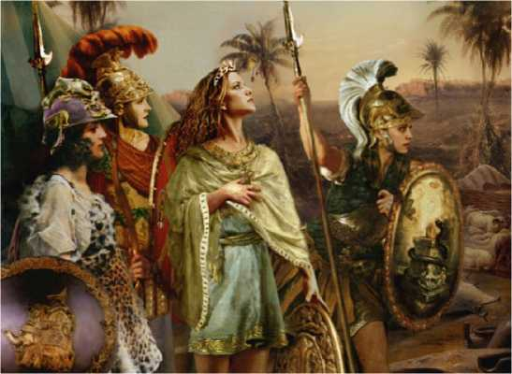

The Barbarian

The barbarian kit from the *CFHB* was one way within 2e to realize the idea embodied in the barbarian class in 5e - the concept of a barbarian from fantasy fiction, wild, untamed, and uncompromising. The principle of barbarism here is that the character is from outside the dominant society of the campaign, a wanderer from wild and distant lands whose presence reaffirms the savage frontier that lies beyond the city's borders.

Three Things Everyone Knows

Consider the following perspectives on the barbarian in the setting:

***The Barbarian is Savage and Heartless.*** Stone- hearted to their enemies, but passionate about slaying them, the barbarian seems to live for conquest and war.

***The Barbarian is Dangerous and Wild.*** An uncontrolled force in this world, the barbarian cannot be directed or manipulated effectively. They are a loose cannon, likely to explode and kill those who would work with them.

***The Barbarian is Exciting and Revolutionary.***

The world most folks live in is dry and boring in the day-to-day, but the barbarian is a breath of fresh air, bringing change with their sword and axe. It's exhilarating.

Making a Barbarian

This kind of barbarian can be a member of the barbarian class, but needn't be - fighters, rangers, and paladins may be attracted to the archetype as well. The easiest way to represent a character like this is simply to have the Outlander background and a high Constitution and Charisma. To match the typical equipment, play a barbarian or a fighter who wields battle axes and longswords (and eschews more advanced weapons).

If you'd like a little more support for this character type, consider the Great Endurance feat and the Brutal Magnetism background feature presented later in this document.

Suggested Build

**AC** 14 — **HP** 14

**Race**: Human

**Class**: Barbarian (Berserker)

**Ability Scores**: Str 16, Dex 14, Con 15, Int 9, Wis 11, Cha 13

**Background**: Outlander (Alternative Feature: Brutal Magnetism)

**Skill Proficiencies**: Athletics, Intimidation, Perception, Survival

**Tool Proficiencies**: Drums

**Languages**: Common, Dwarvish, Orc

**Initial Equipment**: A longsword, two handaxes, an explorer's pack, four javelins, a staff, a hunting trap, a trophy from an animal you killed, a set of traveler's clothes, and a belt pouch containing 10 gp

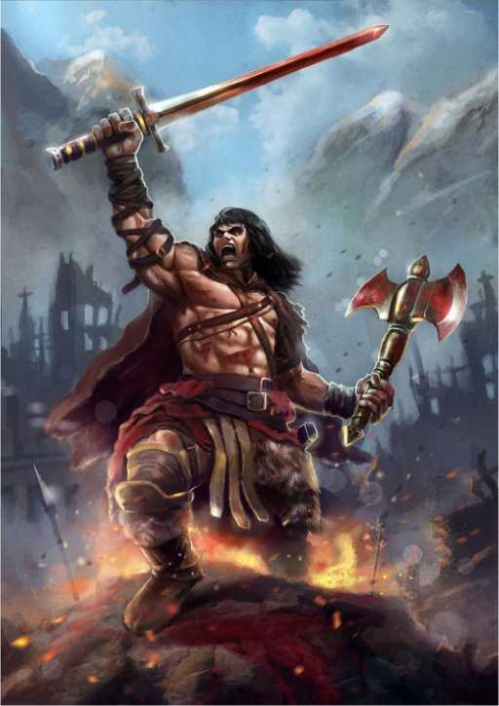

The Beast-Rider

The archetype of the beast-rider is one of a barbaric character whose totem spirit is also a creature he or she rides around on. The bond with the particular kind of animal is deep, tribal, and intimate. Just as the existence of the Barbarian character implies a wild and distant land free of civilization, the Beast-Rider character implies that at least some of those cultures are linked to exotic and powerful animals, perhaps part of the same tribes as totem warriors.

The defining element of the beast-rider is the beast companion that you can ride. This presents a bit of a conversion difficulty in that there's no way to realize this character outside of DM intervention at the moment - there's no official way for your character to ride a bear or a dire wolf. The recommended way around that? The Totemic Companion feat, presented in this document.

Making a Beast-Rider

Aside from the Totemic Companion feat, the beast rider might have a wealth of potential options. Barbarians are likely the most obvious candidates, but rangers can achieve a great rapport with these beasts, and fighters or paladins can make extensive use of them in battle. A beast rider with this option might also consider the Saddle Master feat, which allows them some more exotic riding tricks.

Suggested Build

**AC** 13 — **HP** 14

**Race**: Human (Variant)

**Class**: Barbarian (Totem Warrior - Bear)

**Ability Scores**: Str 15, Dex 13, Con 14, Int 8, Wis 12, Cha 10

**Background**: Outlander

**Feat**: Totemic Companion (Bear)

**Skill Proficiencies**: Animal Handling, Athletics, Intimidation, Perception, Survival

**Tool Proficiencies**: Horns

**Languages**: Common, Giant, Orc

**Initial Equipment**: A greataxe, a shortbow, an explorer's pack, four javelins, a staff, a hunting trap, a trophy from an animal you killed, a set of traveler's clothes, and a belt pouch containing 10 gp

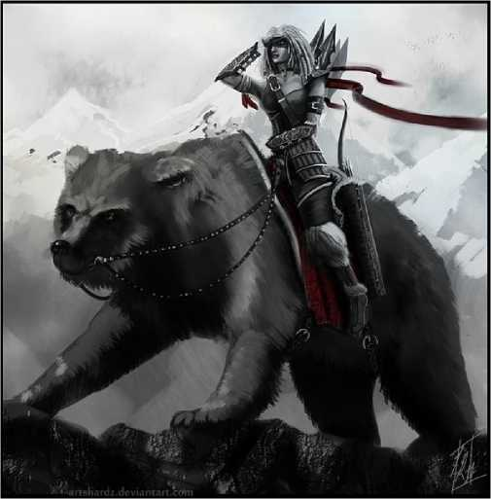

Variant Mounts

The Totemic Companion feat in this document presents animal companions that are relevant to wolf, eagle, and bear totems (matching the totem warrior's options), but other options might include the creatures below. Each of these totems implies a different and distinct tribe.

|  |  |
| --- | --- |
| **Companion** | **Notes** |
| Crocodile | Swimming |
| Giant Bat | Flying |
| Buffalo | Use giant goat statistics |
| Giant Hynea | Combat |
| Giant Lizard | Swimming or Climbing |
| Giant Owl | Intelligent, Flying |
| Giant Spider | Climbing |
| Giant Toad | Swimming |
| Giant Vulture | Intelligent, Flying |
| Lion | Combat |
| Tiger | Combat |

The Berserker

Continuing the theme of “barbaric” PC archetypes, the Berserker implies that some of those characters from beyond the bounds of civilization are dangerous, indeed. Berserkers are intimidating warriors who lose all inhibition, throwing themselves into the fray with reckless abandon. This archetype takes the savage world of the barbarian and the beast-rider and applies it directly to combat.

Three Ways to Go Berserk

Berserkers use a variety of practices and substances to lose their inhibitions and enable their rage. Some examples follow.

***A Poisonous Mushroom.*** Berserkers in the cold forests eat a particular mushroom that grows on dead trees. This mushroom induces hallucinatory trances where wild animal spirits are seen to imbue the berseker with the fury they feel over their kindred being hunted and killed.

***A Drink of the Gods.*** A milky-white drink said to be sacred to the gods of the moon and sea are used by some on the rocky coasts to enter a mindstate similar to drunkenness. The rage these bersekers feel comes from their ancestors, who are jealous of the living.

***Deprivation.*** Berserkers of the desert practice this strategy, which involves starving themselves and dancing until they enter a sort of exhausted trance. Here, a war-god enters their shell of a body, using it to fight on behalf of their people.

Making a Berserker

A berserker is a fairly simple character to recreate in 5e - the berserker barbarian was pretty much made for the job! Emphasize Constitution and melee weapons, and enjoy! With features like Relentless Rage, Persistent Rage, and Mindless Rage, you won't be falling to mental manipulation or hit point damage any time soon. The berserking ability in 5e works a little different in that it doesn't take time to build up before a fight, it doesn't prevent healing, and it doesn't mean you're prone to attacking your allies, but those are drawbacks that are no longer necessary in 5e. You might want to consider the Great Endurance feat to represent a berserker's implacable nature. You might also want to consider the Tribal Affiliation feature to embody a character who is well respected by their people.

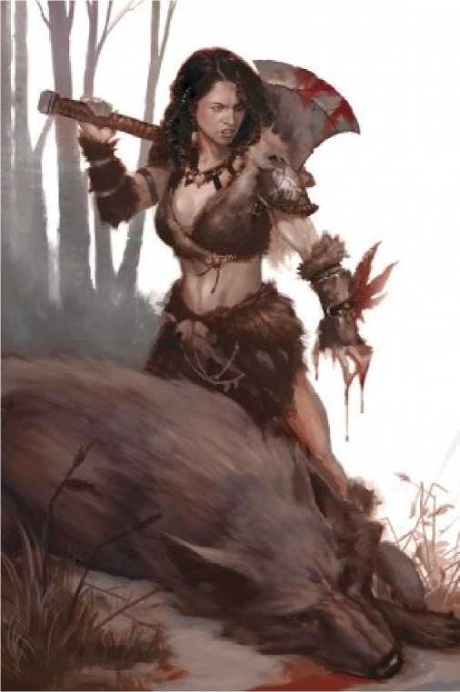

Suggested Build

**AC** 14 — **HP** 14

**Race**: Human

**Class**: Barbarian (Berserker)

**Ability Scores**: Str 16, Dex 14, Con 15, Int 9, Wis 13, Cha 11

**Background**: Outlander

**Skill Proficiencies**: Athletics, Intimidation, Perception, Survival

**Tool Proficiencies**: Horns

**Languages**: Common, Elven, Orc

**Initial Equipment**: A greataxe, two handaxes, an explorer's pack, four javelins, a staff, a hunting trap, a trophy from an animal you killed, a set of traveler's clothes, and a belt pouch containing 10 gp

The Cavalier

The archetype of a cavalier is the knight-in- shining-armor archetype, a character whose noble blood and combat prowess have saved the lives of countless innocents and who has become a hero in their own land because of their exploits. Cavaliers can hail from anywhere with an elite cavalry and a certain level of civilization that allows for a noble class. It might be that in your world certain noble families are more associated with this archetype than others, or that the nobles in the region depend on cavaliers to defend them against enemy armies or monsters on the hinterlands.

Three Tenents of Chivalry

Consider the following ideas of chivalry when roleplaying your cavalier:

***Protect the Weak.*** You were born with power and influence to spare. Use it to protect and support those weaker than you, so that they have a chance in this destructive world.

***Respect Your Place.*** Don't defy those with greater standing than you, and don't lift those lower up to be your equal unless the earn it. Know your place in the hierarchy, and be loyal to it.

***Be Known for Honor.*** Your reputation is your life. You must be well-loved and well-respected in the lands you travel, else you may as well be a mercenary or a vagabond. Advertise your presence, and don't let black marks besmirch your name.

Making a Cavalier

The simplest way to model this is to take the Noble background, wear heavy armor, get a mount, and use lances, swords, and maces. Having a good Charisma and a good Wisdom will model many elements of a cavalier, so being a Paladin is likely (elements like the Aura of Courage can especially encourage this), though a Fighter with these robust scores can also make a good cavalier. Grab the Mounted Combatant feat, if you're using feats in your game, to put the cherry on top. Also consider the Saddle Master and Courtly Grace feats as potential choices for making a cavalier who is good with a mount outside of a fight, and who is also skilled with their words.

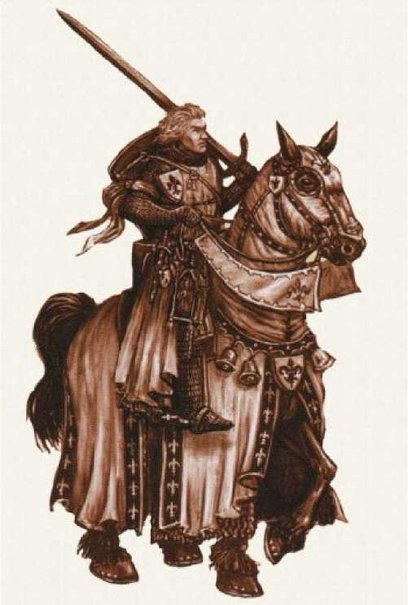

Suggested Build

**AC** 18 — **HP** 11

**Race**: Human (Variant)

**Class**: Paladin (Oath of Devotion)

**Ability Scores**: Str 15, Dex 8, Con 13, Int 10, Wis

12, Cha 14

**Background**: Knight

**Feat**: Mounted Combatant

**Skill Proficiencies**: Athletics, History, Insight, Intimidation, Persuasion

**Tool Proficiencies**: Dragonchess set

**Languages**: Common, Dwarven, Elven

**Initial Equipment**: A lance, a shield, five javelins, an explorer's pack, chain mail, a holy symbol, a set of fine clothes, a signet ring, a scroll of pedigree, and a purse containing 25 gp

Kit: The Gladiator

The gladiator archetype is born out of the blood­stained sands where a brutal form of public entertainment takes place: life-and-death struggle, for the amusement of the audience. These events may be a regular part of every day life, or they may be relegated to cities where the cruel or the barbaric exercise power. The existence of gladiators implies the existence of arenas for them to fight in, though said arenas don't need to be local to the current action of the campaign.

Three Gladiator Styles

The build below presents a “nautical” gladiator, but there are many other styles you might entertain:

***The Beast-Fighter.*** Thrown into a ring with lions, tigers, or even more monstrous foes, a beast-fighter knows how to battle a hungry, enraged, desperate animal. Clever, cautious, and instinctive, this gladiator fights with a hunter's cunning.

***The Boxer.*** The only piece of equipment that these gladiators wear in the ring is the *cestus*, a metal gauntlet. They are skilled boxers and wrestlers whose pugilistic skills are deadly.

***The Charitoteer.*** These gladiators fight from a chariot, often circling their intended prey and harassing them with ranged attacks.

Making a Gladiator

The easiest way to port this character type into 5e is to make a character that uses short swords, nets, and tridents. Proficiency with land vehicles can include chariots. A decent Dexterity is useful, and helpful as the archetype typically wears lighter armor. The Entertainer background (specifically, the Gladiator variant) works very well for this character type. Be sure to get proficiency in land vehicles if you're a chariot racer, as well.

Because of the light armor, monks and barbarians often make good gladiators, but battlemaster fighters probably possess the most gladiator-like suite of abilities, having many options for disabling their enemies and aiding their allies.

You might additinally take the Tumbler feat to represent your acrobatic prowess, or the Gladiator fighting style to encourage you to use some iconic gladiator weapons.

Suggested Build

**AC** 16 — **HP** 12

**Race**: Human

**Class**: Fighter (Battlemaster)

**Ability Scores**: Str 16, Dex 14, Con 15, Int 9, Wis

11, Cha 13

**Background**: Gladiator

**Skill Proficiencies**: Acrobatics, Athletics, Intimidation, Performance

**Tool Proficiencies**: Disguise kit, horns **Languages**: Common, Orc

**Initial Equipment**: chain mail, a trident, a short sword, two handaxes, an explorer's pack, a net, the favor of an admirer, a costume, and a belt pouch containing 15 gp.

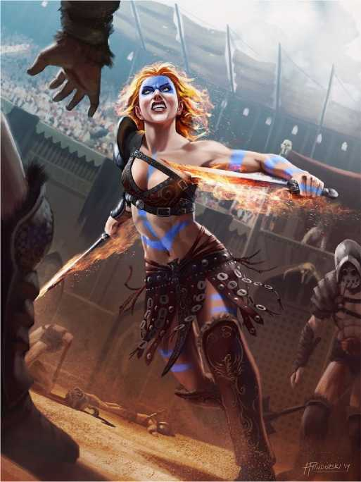

Kit: The Myrmidon

The Myrmidon kit presents an archetype of a professional soldier. Such an individual might be part of an ongoing defense force, part of a town guard, a mercenary for hire, or a conscript that never left. Either way, they owe allegiance to the one who pays for their food and drink, typically a local noble or the taxes of the people. Though in times of war, people are happy to pay, in times of peace, taxes and the like can make the soldiers seem like parasites, leading many to become hired swords.

Three Mercenary Guilds

Myrmidons might be members of standing armies, but they might be simple mercenaries, hiring their blade to the highest bidder. Some guild ideas below:

***The Constellation Academy.*** Organized primarily by former members of various powerful armies, these sell-swords have left behind ideology for lucrative roles in various conflicts abroad. Known for their craftily worded contracts and a certain disregard for civilian casualties, they tend to attract a bit of controversy when hired, though they are quite effective at what they do.

***The Ravens.*** This mercenary band of sombre warriors is known to go into a battlefield after much of the battle is already fought, tackling survivors and undead stirred up in the area.

***The Triple Shield.*** Three warriors founded this “security organization” many years ago, and now it is employed in defending those who must travel through war zones for one reason or another. They're reliable protectors, but motivated primarily by money - unforeseen disasters raise the cost while you're still on the road.

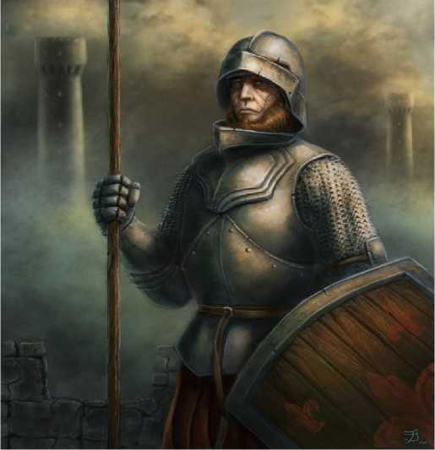

Suggested Build

**AC** 18 — **HP** 12

**Race**: Human

**Class**: Fighter (Champion)

**Ability Scores**: Str 16, Dex 14, Con 15, Int 11, Wis 13, Cha 9

**Background**: Soldier

**Skill Proficiencies**: Athletics, History, Intimidation, Survival

**Tool Proficiencies**: Dragonchess set, land vehicles **Languages**: Common, Orc

**Initial Equipment**: chain mail, a longsword, a shield, a light crossbow and 20 bolts, an explorer's pack, an insignia of rank, a trophy taken from a fallen enemy, a set of bone dice, a set of common clothes, and a belt pouch containing 10 gp.

Making a Myrmidon

There's little in this kit that isn't encompassed by the Soldier background. Choose the History skill, and you're essentially good to go!

Most myrmidons are likely fighters, skilled warriors whose practice and defensive prowess has yielded results on the battlefield. Fighters are more reliable than barbarians and rangers, and more practical than paladins, making them well suited to the hired work that myrmidons do.

Kit: The Noble Warrior

The archetype of the Noble Warrior is one who has been trained for war (and, especially, for command) as a birthright. Gracious, chivalrous, generous, and gallant, the ideal noble warrior upholds the highest ideals of the society in which they live. Of course, noble warriors who have more arrogance than idealism may be cads with a cruel streak. From a world-building perspective, the important thing for a noble warrior is to have a society of nobles they can fit into - a wealthy family or landed aristocracy, typically.

Three Noble Houses

Noble warriors hail from notable bloodlines, and so the context of their upbringing can be very important.

***House Krisela.*** A once-powerful family fallen on hard times due to the gambling and debts of an uncle with more money than sense, House Krisela clings tenaciously to their fading glory as a symbol for what they are, fighting the idea that they are anything less than noble.

***House Olyndrav.*** This nouveau riche merchant family is making a bid for true aristocracy after having grown wealthy and powerful on selling trade caravan insurance. Their children are encouraged to become even more glorious and powerful than their parents, which can lead to some terrible pressures on the young generation.

***House Wojaram.*** An old family from a bleak town in the hinterlands, house Wojaram's children have often struggled to find someone to marry, as their land is wind-swept cliffside without much in the way of resources.

Making a Noble Warrior

The main method here is to simply take the Noble background, and then take levels in a warrior class such as Fighter or Paladin. For a character who goes a bit against type, consider being a rogue (especially an assassin) for a stronger “refined and intelligent fighter” feel. You might also pick up the Courtly Grace feat from this document, for a character who is able to move among noble society easily.

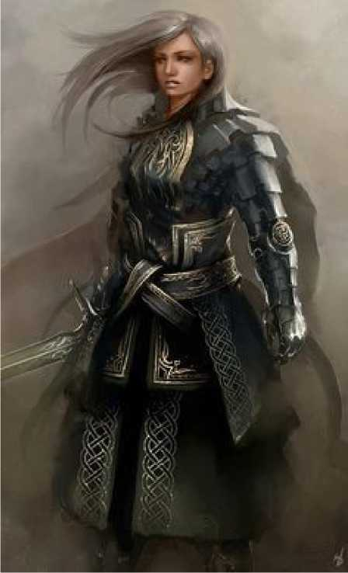

Suggested Build

**AC** 18 — **HP** 11

**Race**: Human (Variant)

**Class**: Fighter (Battle Master)

**Ability Scores**: Str 15, Dex 8, Con 13, Int 12, Wis 10, Cha 15

**Background**: Noble

**Feat**: Courtly Grace

**Skill Proficiencies**: Athletics, Animal Handling, History, Intimidation, Persuasion

**Tool Proficiencies**: Dragonchess set

**Languages**: Common, Dwarven, Elven

**Initial Equipment**: chain mail, a longsword, a shield, a light crossbow and 20 bolts, a dungeoneer's pack, a set of fine clothes, a singet ring, a scroll of pedigree, and a purse containing 25 gp

Kit: The Peasant Hero

The idea of the Peasant Hero is a character who is not from the world of the powerful and noble, but who enters it by virtue of some remarkable deed. Peasant heroes may be a surprisingly common origin in a land of monsters and agriculture: not every countryside is well-protected by troops.

Three Humble Origins

Peasant heroes are already the hero of some small local village. Below are three possible stories you might have for how your peasant hero started out.

***An Adventurer's Protege.*** An old adventurer lives in your town. Though most people consider them a dangerous and mysterious figure, you're drawn to the old person in the hut on the outskirts of town. They taught you everything you needed to know so that when the past caught up with them in the form of a group of bandits hired to take them out, you were prepared to defend your town.

***The Lost Parent.*** You were raised by one parent; the other one was never present. You grew up wondering what happened, but it was a taboo family topic, that few talked about. It was a fateful day when you fled home, grabbing your parent's old sword and hiding out in the woods. The goblins nearly got you then, but you managed to fight them off. When you returned home, the look on the eyes of your family said it all: there was no stopping you from following in your lost parent's footsteps.

***The Destroyed Homeland.*** You were the last survivor. When the orcs came over the ridge and began to torch everything, you hid while the town around you burned. When the dust settled, you ventured to see what had happened...and you saw everything you knew had been reduced to blood and ash.

Making a Peasant Hero

This archetype holds little that the Folk Hero background doesn't already hold. Pick cheap weapons and armor, and use short swords, spears, bows, and other rustic weapons to complete the look.

You may consider the Farmer or Fisher feats if you want to be especially close to your early life.

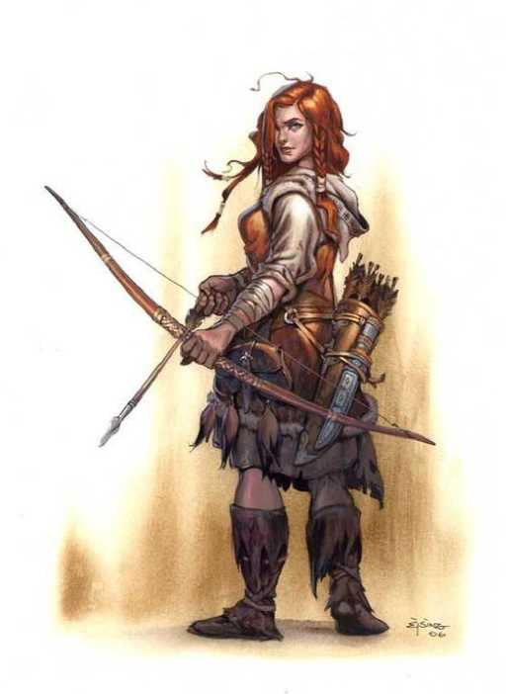

Suggested Build

**AC** 18 — **HP** 12

**Race**: Human

**Class**: Fighter (Champion)

**Ability Scores**: Str 16, Dex 14, Con 15, Int 11, Wis 13, Cha 9

**Background**: Folk Hero

**Skill Proficiencies**: Animal Handling, Athletics, Perception, Survival

**Tool Proficiencies**: Brewer's supplies, land vehicles

**Languages**: Common, Goblin

**Initial Equipment**: chain mail, a longsword, a shield, two handaxes, an explorer's pack, a set of brewer's supplies, a shovel, an iron pot, a set of common clothes, and a belt pouch containing 10 gp

This archetype describes any character who makes a living by robbing and plundering others in the wilderness in between civilization. Living in makeshift camps and fortresses, these outlaws prey on travelers and merchants, making the roads a dangerous place.

Three Kinds of Outlaws

While all outlaws share certain characteristics, there can be significant diversity in the activities, habits, and motives for banditry. Consider some of the following ideas when developing your outlaw character:

***The Once-Pround Army.*** The outlaws that haunt the countryside were once members of the military, trained for battle and driven at the enemies of the kingdom. Once the kingdom emerged victorious, they were left without a role or a job, but with violent memories and a handy sword arm. These outlaws took to robbing others as a way to survive in a world that no longer needed their skills.

***Freebooters.*** These outlaws delight in being outside the law. Civilization is too stuffy and controlling, too many responsibilities and to few opportunities. The freebooters make a living with their blades where they can - occasionally by robbing a wealthy merchant vessel or such. Violence isn't their goal, and neither is massive wealth, but one can use those tools to gain more freedom.

***Revolutionaries.*** These outlaws are people who claim the moral high ground, fighting against a law or nation they see as corrupt and wicked. Some of these revolutionaries hold to a high moral standard, provide services for those displaced by the government, and attract high- minded ideologues to their cause. Others are thinly veiled terrorist bands claiming a moral superiority they don't have. The line between one and the other can be quite blurry at times, even in a single individual.

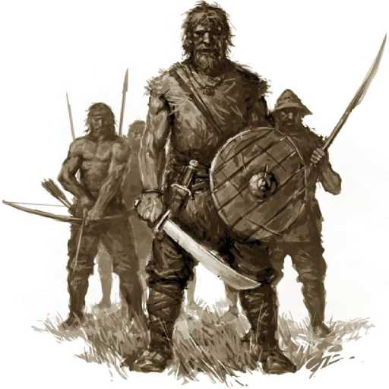

Making an Outlaw

There are several backgrounds that make for compelling outlaws, depending on the kind of outlaw you want to be. Criminals, outlanders, urchins, even former soldiers and nobles might find themselves cast in with the outlaws. A sailor, re-skinned to be land-based (or a pirate) may also be well suited to the role.

Suggested Build

**AC** 16 — **HP** 12

**Race**: Human

**Class**: Fighter (Battle Master)

**Ability Scores**: Str 15, Dex 16, Con 14, Int 11,

Wis 13, Cha 9

**Background**: Pirate

**Skill Proficiencies**: Athletics, Intimidation, Perception, Survival

**Tool Proficiencies**: Navigator's tools, water vehicles

**Languages**: Common, Gnomish

**Initial Equipment:** leather armor, a longbow and 20 arrows, a scimitar, a shield, two handaxes, an exploer's pack, a belaying pin (club), 50 feet of silk rope, a lucky charm, a set of common clothes, and a belt pouch containing 10 gp

Kit: The Samurai

The Samurai archetype presented in *CFHB* is based more on movies and stereotypes than on the historical samurai (who would be better off looking to the Noble Warrior kit or the Cavalier kit), but it can be fun to play with those tropes as well. Loyal, noble, and from a distant land, the samurai archetype serves to represent a world far apart from the land of the campaign setting (if you're actually setting a game in a pseudo­Japanese land, you're better off not using this kit).

Three Tenets of Bushido

The following ideals are inspired by the historical code of the samurai, but adopted to give something of the flavor without being a precise reproduction. You might consider them when playing your samurai.

***Obedience and Honor.*** Your reputation as a loyal and obedient instrument of your lord's will should be vital to you. To defy your lord or even to simply be seen as defiant would be a black mark on your name.

***War and Art.*** As you fight, you should be an instrument of power and beauty, a moving instrument of death. Master creative arts as you master martial arts, and recognize the kinship between them.

***Self-Sacrifice.*** You are dedicated to something greater than yourself, a kingdom, a people, a nation. Giving your life in service of this higher ideal is the best death a mortal can ask for, so embrace it, if it comes.

Making a Samurai

Using the long sword and the long bow as your archetypal weapons, wearing heavy armor, and taking the Noble or Soldier backgrounds will get you most of the way to this kind of samurai.

The Courtly Grace and Saddle Master feats are useful to emphasize the courtly nature or the mounted prowess of a samurai. If you'd like to model the *kiai* shout presented in the *CFHB*, the Kiai Fighting Style presented her emight be a good fit.

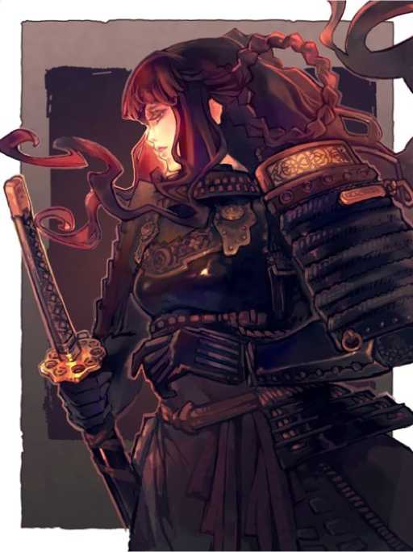

Suggested Build

**AC** 18 — **HP** 12

**Race**: Human (Variant)

**Class**: Fighter (Battle Master)

**Ability Scores**: Str 15, Dex 8, Con 14, Int 10, Wis 12, Cha 14

**Background**: Knight

**Feat**: Courtly Grace

**Skill Proficiencies**: Animal Handling, Athletics, History, Intimidation, Persuasion

**Tool Proficiencies**: Dragonchess set

**Languages**: Common, Dwarven, Gnomish

**Initial Equipment:** Chain mail, a longsword, a set of kote (equivalent to a shield), a light crossbow and 20 bolts, a dungeoneer's pack, a set of fine clothes, a singet ring, a scroll of pedigree, and a purse containing 25 gp

Kit: The Paleo-Warrior

Called the “savage” in the *CFHB*, this kit describes a particular archetype of a warrior who hails from a land with limited technology, who finds themselves alongside our more typical pseudo-medieval characters. Such a character, of course, need be no more “savage” than any mercenary or crusader from more familiar lands, but they have an array of abilities culled from a life of hunting and gathering that more specialized warriors from more culturally complex areas might have.

Stone and Bone Weapons

The metal parts of piercing metal weapons can be replaced with bits of stone or bone and can remain very effective. Stone-tipped spears, bone daggers, or stone-tipped hunting arrows can all be used with nearly the effectiveness of their iron and steel counterparts, and often for much cheaper.

If you roll a 1 on an attack roll with a stone or a bone weapon, it shatters on impact with some object or bit of the target.

Making a Paleo-Warrior

The key here is light armor. You can make a fighter who specializes in ranged attacks and emphasizes Dexterity (which would be in line with the hunting practices of many hunter-gatherer tribes), or you can consider using the barbarian class to model a strong, tough melee machine. A Totem Warrior wouldn't be far away from the semi-magical abilities that the paleo-warrior is described as having in the *CFHB*. Other ways to access that minor magical ability include the Magic Initiate feat (Druid is especially apt), the Ritual Caster feat (again, druid magic being choice), or gaining levels as a Ranger (which fits the hunter model of the paleo-warrior nicely as well).

You might want to consider the Farmer or Fisher feats from this document to help represent the paleo-warrior's close bond with their low-tech roots.

Suggested Build

**AC** 14 — **HP** 11

**Race**: Human (Variant)

**Class**: Ranger (Hunter)

**Ability Scores**: Str 12, Dex 15, Con 13, Int 10,

Wis 14, Cha 8

**Background**: Outlander

**Feat**: Ritual Caster (druid)

**Skill Proficiencies**: Animal Handling, Athletics, Insight, Perception, Survival

**Tool Proficiencies**: Drums

**Languages**: Common, Goblin, Orc

**Initial Equipment:** leather armor, a spear, a handaxe, an explorer's pack, a longbow and 20 arrows, a staff, a hunting trap, a trophy from an animal you killed, a set of traveler's clothes, and a belt pouch containing 10 gp

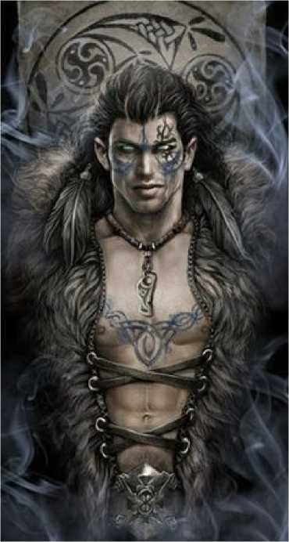

Kit: The Swashbuckler

The swashbuckler is an archetype of grace, panache, and wit, clever and light on their feet. Swashbucklers tend to be from relatively advanced cultures, and often truck in ships, sailing, piracy, and other nautical tropes. They are almost always some sort of wealthy, though their lives as swashbucklers often means they are far from the wealth that they can leverage, and they may be more in search of a big payday. Regardless, they are educated and refined, entirely at home in high society.

Three Tales of Daring-Do

Swashbucklers are thrown into the winds of adventure as a matter of course, and can rarely be found in one place for long. Perhaps your swashbuckler has had one of the following experiences, or knows some one who has:

***The Jealous Partner.*** Your travels have brought you far and wide over this land, but never have you come closer to death than when you were with a particular lover in a particular town, and their partner entered the room. Pants-less, you fled the scene in a hurry, and spent the afternoon dodging curious onlookers in a desperate bid to hide our unmentionables.

***The Pirate's Gold.*** Once upon a time, when you were captive in a cruel pirate's hold, you managed to trick them into believing you knew where a secret cache of gold was located. Hoping for a miracle, you lead them deep into the jungle, where some irate locals took you all captive. By a twist of fate, your bonds were loose, and you managed to give everyone the slip and sail back on the pirate's own ship!

***The Lost King.*** You once ran aground on an island that seemed abandoned, but when you explored it a bit, you came to a vast ruin shrouded in greenery. You found one man living in that ruin, seated on the throne in the main building like he owned the place, but saw no one else. When the man chased you out, you fled, and haven't been back to this day.

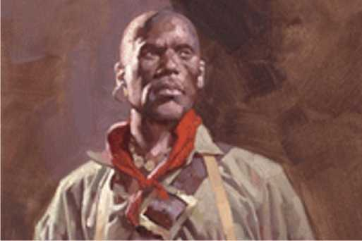

Making a Swashbuckler

A good Charisma, a good Dexterity, and a favoring of light weapons point most directly to the Rogue class to embody this archetype (perhaps with a Sailor background). Multiclassing can be used to make a more robust rogue/fighter, especially one focusing in one-handed weapons. You could also become a bard, unlocking magical secrets in your travels.

The Courtly Grace feat is a nice touch for a swashbuckler who wants to hew closely to the noble roots.

Suggested Build

**AC** 13 — **HP** 12

**Race**: Human (Variant)

**Class**: Fighter (Battle Master)

**Ability Scores**: Str 12, Dex 15, Con 13, Int 10,

Wis 8, Cha 15

**Background**: Sailor

**Feat**: Courtly Grace

**Skill Proficiencies**: Acrobatics, Athletics, Intimidation, Insight, Perception

**Tool Proficiencies**: Navigator's tools, water vehicles

**Languages**: Common, Gnomish

**Initial Equipment:** leather armor, a longbow and 20 arrows, a rapier, a shortsword, a light crossbow with 20 bolts, an exploer's pack, a belaying pin (club), 50 feet of silk rope, a lucky charm, a set of common clothes, and a belt pouch containing 10 gp

The Nomad

Dubbed the “wilderness warrior” originally, the nomad archetype is drawn from those who travel through extreme territories such as deserts or tundra or even the ocean itself. These people are from far abroad, distant lands, and the archetype is to serve as the voice of these distant places in the pseudo-medieval milieu.

Three Lands of the Nomads

The nomad is a broad concept, and many different regions may give birth to the nomadic lifestyle. Consider the following when designing your nomad:

***The Empty Sands.*** This nomad hails from endless dunes under a beating sun. Loose, flowing robes and turbans and veils adorn them, and they travel in massive camel caravans between places of water. They are frequent traders, traversing lands that few others dare to.

***The Endless Seas.*** This type of nomad travels great storm-tossed seas on rugged ships made for long journeys. They are great fisherfolk, and have a knack for getting plenty of water and food out of the barren expanses of blue. Their ships make great trading vessels between the distant ports they visit.

***The Frigid Steppes.*** These vast expanses of dry plains are in the grip of icy winds and severe dust-storms. The stunted grasses can be grazed only by especially hardy horses, and these nomads are skilled herders, living almost their entire lives in the saddle as they go from region to region, following the forage.

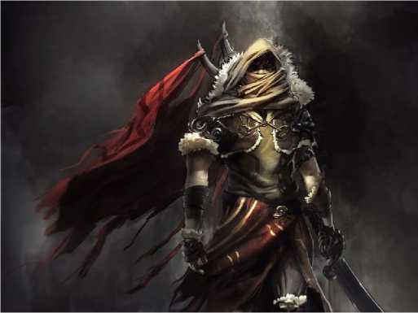

If you are a nomad from a mount-using culture, the Saddle Master feat can be used to emphasize that aspect of your people.

Suggested Build

**AC** 14 — **HP** 12

**Race**: Human

**Class**: Fighter (Champion)

**Ability Scores**: Str 14, Dex 15, Con 13, Int 10, Wis 12, Cha 8

**Background**: Outlander

**Skill Proficiencies**: Animal Handling, Athletics, Perception, Survival

**Tool Proficiencies**: Drums

**Languages**: Common, Dwarvish, Elvish

**Initial Equipment:** leather armor, a longbow and 20 arrows, a scimitar, a lance, two handazes, an explorer's pack, a staff, a hunting trap, a trophy from an animal you killed, a set of traveler's clothes, and a belt pouch containing 10 gp

Making a Nomad

Like the Berserker, the Barbarian, and the Beast­Rider, Nomads can often be represented with the Outlander background. In the case of the Nomad, investing in a high Constitution and high Wisdom and grabbing the Survival skill from somewhere is often enough to embody the archetype. You might want to consider going with a ranger or a barbarian, rather than a fighter.

Equipment

Weapon and Armor Analogues Similar to how various classical Asian weapons have analogues in the 5e PHB, these new weapons and armor also often have analogues.

Weapons

|  |  |
| --- | --- |
| **Original Weapon** | **PHB Equivalent** |
| Atl-Atl | Javelin |
| Belaying Pin | Club |
| Bo Staff | Quarterstaff |
| Chain | Flail |
| Daikyu | Longbow |
| Gaff | Sickle |
| Main-Gauche | Dagger |
| Nunchaku | Flail |
| Naginata | Glaive |
| Tetsubo | Quarterstaff |
| Sai | Dagger |
| Shuriken | Darts |
| Stiletto | Dagger |
| Cutlass | Scimitar |
| Drusus | Shortsword |
| Katana | Longsword |
| Sabre | Scimitar |
| Wakizashi | Shortsword |
| Armor |  |
| **Original Armor** | **PHB Equivalent** |
| Thracian Gladiator | Leather |
| Gallic Gladiator | Scale Mail |
| Samnite Gladiator | Half plate |
| Kote | Shield |

New Weapons

Not all the weapons presented in the *CFHB* have good analogues. The Cestus, Bolas, and Lasso are presented here as new weapons.

**Weapon Cost Damage Weight Properties**

*Martial Melee Weapons*

Cestus 1 gp 1d4 bludgeoning 2 lbs

*Martial Ranged Weapons*

|  |  |  |
| --- | --- | --- |
| Bolas | 2 gp 1d4 bludgeoning 2 lbs | Special, thrown (range 10/30) |
| Lasso | 2 gp - 1 lb | Special, thrown (range 5/10) |

Weapon Descriptions

Below are descriptions of the new weapon. Weapons with special rules have those rules described here.

***Bolas.*** Bolas are a hunting tool that has occasionally been converted for use in battle. It consists of a series of weights (usually stones) connected by a leather strap, and is spun in a method similar to a sling. When released, the weights wrap around a creature, and also strike it with significant force.

A Medium or smaller creature hit by bolas is restrained. A creature restrained by the bolas can free themselves by using their action to cut or untangle the ropes.

A Medium or smaller creature hit by a critical hit with the bolas is unable to use their arms. Thus, they cannot use weapons, shields, or spells with somatic components. They are not restrained, however. A creature who cannot use their arms can be freed by another creature as an action, or can free themselves by spending 1 minute worming out of the ropes.

***Cestus***. A cestus is simply an armored gauntlet used for punching, loaded with spikes and rivets. They are popular among gladiators.

Your hand is free when you are weilding a cestus.

***Lasso.*** A lasso is a long rope with a loop at the end - the loop is thrown over a target and pulled taught.

A Large or smaller creature hit by a lasso cannot move more than 10 feet from the attacker as long as the lasso is intact, and is knocked prone. The lasso can be cut by using an action.

A Large or smaller creature hit by a critical hit with a lasso is not knocked prone, but is unable to use their arms. Thus, they cannot use weapons, shields, or spells with somatic components. A creature who cannot use their arms can be freed by another creature as an action, or can free themselves by spending 1 minute worming out of the ropes.

Springs and Sheaths

There are two items presented in the *CFHB* that are suitable for those who wish to appear unarmed. The first is a spike which can spring out from some hidden cache (such as the end of a staff or a spike hidden in a sword's hilt) so that the character can go from unarmed to armed in a moment's notice. The second is a sheath which can pop out the weapon stored in it, to be grabbed and wielded almost instantly by the character. Both of these items are of questionable legality, but black markets may supply them.

***Spring Spikes.*** These are installed when making an item, for an extra 5 gp. When the spring spike is triggered, the item can be wielded as a simple melee weapon, dealing 1d3 piercing damage on a hit. It can instead turn a bludgeoning weapon into a piercing weapon.

***Spring Sheaths.*** These sheaths can be made for 15 gp. When triggered, the weapon in the sheath is immediately wielded in the hands, requiring no additional time or action to draw.

Magic Items

There's plenty of room for some new magic items!

Bracelet of Charms

*Wondrous item, uncommon*

This well-made bracelet is crafted of gold links, and small golden charms in the shape of various weapons adorn it. Those charms are actually weapons that are stored in the *bracelet of charms*, able to be called forth and into hand by anyone who speaks the command word while wearing the bracelet.

While a weapon is called forth from the bracelet, no other weapon can be called from it (even if the weapon called forth has been lost, stolen, or destroyed). When no weapon is called from the bracelet, a weapon can be put into it, as an additional charm upon its golden links. One who carries the *bracelet of charms* can only put a weapon onto its links that they are proficient in wielding, and only by holding the weapon in hand. Weapons are stored in whatever condition they were at the time they were turned into a charm - a broken bow or a rusted dagger or an empty quiver remains the same when called forth later.

There's no limit to the number of charms that can be put on the bracelet, but the bracelet can only be used to call fourth four weapons in a day (and only one at a time). A weapon that is currently a charm on the bracelet can be taken out of the bracelet's array, but only if the bracelet is not currently being worn.

Cage of Shelter

*Wondrous item, rare (requires attunement)*

This item's inert form is a large birdcage, which has been folded flat into a disc. By placing the cage on the ground and clapping two or three times, an attuned owner can cause it to become either a sturdy metal-framed tent that holds up to 8 people, or a strong 10 foot by 10 foot cell whose door benefits from a constant *arcane lock* spell (functioning as if you cast the spell when you create the cell).

Clapping again turns the cell or the tent back into the neatly folded birdcage, though this doesn't function if there are creatures inside the structure.

Charm of Favor

*Wondrous item, uncommon*

This item is often a small statuette of a deity, and it is always given specifically and explicitly by a deity to a creature that earns it. When the statuette is shattered on the ground, and a prayer said, the prayer is answered by the deity. The deity evaluates the prayer, and so only grants a prayer that is in keeping with the deity's own ethos, and only one that benefits the person to whom this charm is bestowed (regardless of who broke it).

Rings of Readiness

*Wondrous item, uncommon*

These two fairly plain iron rings - one suitable to be worn on a finger, another about 2 inches in diameter - are mystically tethered to each other. The larger ring can be attached to part of an object (and will magically shrink to encircle a smaller piece of an object, such as the hilt of a blade). When the smaller ring is worn and the magical phrase inscribed on it is spoken, the object that the larger ring is on is magically transported to the character wearing the smaller ring, ready to be used. This means weapons are teleported into your hand, clothing is teleported onto the right body part, and even a suit of armor can be teleported to be immediately worn. Objects that can't currently be used instead appear next to the bearer of the smaller ring, such as someone using two swords summoning a third.

Sheath of Holding

*Wondrous item, uncommon*

This ordinary knife sheathe - one made for a rather large knife - uses a magic like that of the *bag of holding*, but for swords. A sword of any size can be stored in a *sheath of holding*, from dagger to greatsword (though the larger weapons' immense hilts might look a little strange sticking out of a small sheath).

Saddle of the Spirit-Horse

*Wondrous item, rare (requires attunement)*

This quality leather saddle is worn with use. If it is worn by a mount for three days (as a saddle would normally be worn), a bond is set up between the saddle, the mount, and the attuned rider. If the horse happens to die, the spirit of the mount comes to rest in the saddle for 24 hours before it departs for the afterlife. When the spirit awakens, the saddle rises into the air and floats there, born aloft by the invisible spirit of the mount. The spirit carries the saddle as it did in life, but tirelessly, over any terrain (it gains no powers aside from this tirelessness, so it can't fly or walk on water or anything).

A mistreated mount will become a vengeful spirit after death, and if such a creature resides in the saddle, it will do its utmost to kill any rider, such as by leaping off of cliffs or running headlong into danger, or bucking the rider off.

Shield of Medusae

*Shield, rare (requires attunement)*

This metal shield is polished to a fine sheen on its outer edge, and when looked at from the inside, the shield itself is completely invisible. These two traits make it especially useful for fighting creatures with a gaze attack.

Firstly, someone wielding this shield can see through it while still being protected by it. Furthermore, while they look through the shield, they are immune to the petrifying gazes of creatures like medusae and basilisks (and other creatures who turn to stone with a glance). If such a creature targets the shield bearer with a gaze attack, the gaze is reflected back onto the creature, who targets themselves with the effect.

Game Rules

***High-Quality Armor.*** If someone wearing this armor suffers a critical hit, the creature that scored the critical hit must re-roll the attack roll. If that second attack roll misses, the critical hit is turned into a normal hit. The armor then loses this trait until it is repaired.

Expanded Proficiencies

The crafting rules on pg. 187 cover making armor pretty well in general, but you may want to add a bit of granularity.

Weapon & Armor Quality

Usually, you can simply make normal weapons and suits of armor if you have access to the raw materials, an appropriate crafting facility, some money, some time, and proficiency with the right artisan's tools. As an option, the DM can choose to have the crafter make a proficiency check instead.

If you use this option, there is less assurance of getting the item you seek, but you may also end up with a high-quality item, depending on your proficiency check results.

At the end of your crafting period, make an Intelligence (artisan's tools) check, with a DC that varies based on the weapon or armor you wish to craft.

If you fail by 5 or more, the thing you produce is clearly of inferior quality, useful for little more than slag.

If you fail by 4 or less, the object you make is low-quality, but this low quality isn't obvious - a character proficient in the item can tell with an Intelligence check (that they can add their proficiency bonus to) that beats your original crafting check, if they actively inspect the item.

If you succeed, you make the object normally.

If you succeed and your total is 10 or more above the DC, you have made a high-quality item (and this is clear to anyone with proficiency in the item).

Armor

|  |  |  |  |  |
| --- | --- | --- | --- | --- |
| **Item** | **Tool** | **DC for Quality** | | |
| Low | Avg. | High |
| Padded Armor | Weaver's | 6 | 10 | 20+ |
| Leather Armor | Leatherworker's | 6 | 10 | 20+ |
| Studded  Leather Armor | Leatherworker's | 6 | 10 | 20+ |
| Hide Armor | Leatherworker's | 6 | 10 | 20+ |
| Chain Shirt | Smith's | 6 | 10 | 20+ |
| Scale Mail | Smith's | 8 | 12 | 22+ |
| Breastplate | Smith's | 9 | 13 | 23+ |
| Half Plate | Smith's | 12 | 16 | 26+ |
| Ring Mail | Smith's | 8 | 12 | 22+ |
| Chain Mail | Smith's | 8 | 12 | 22+ |
| Splint | Smith's | 8 | 12 | 22+ |
| Plate | Smith's | 12 | 16 | 26+ |
| Shield | Smith's | 6 | 10 | 20+ |

***Low-Quality Armor.*** If someone wearing this armor suffers a critical hit, the armor is ruined, and provides no additional protection

|  |  |  |  |  |
| --- | --- | --- | --- | --- |
| Weapons  **Item**  Club | **Tool**  Woodcarver's | **DC for Quality** | | |
| Low  6 | Avg.  10 | High 20+ |
| Dagger | Smith's | 6 | 10 | 20+ |
| Greatclub | Woodcarver's | 6 | 10 | 20+ |
| Handaxe | Smith's | 6 | 10 | 20+ |
| Javelin | Woodcarver's | 6 | 10 | 20+ |
| Light Hammer | Smith's | 6 | 10 | 20+ |
| Mace | Smith's | 6 | 10 | 20+ |
| Quarterstaff | Woodcarver's | 6 | 10 | 20+ |
| Sickle | Smith's | 6 | 10 | 20+ |
| Spear | Smith's | 6 | 10 | 20+ |
| Light Crossbow | Tinker's | 8 | 12 | 22+ |
| Dart | Smith's | 8 | 12 | 22+ |
| Shortbow | Woodcarver's | 8 | 12 | 22+ |
| Sling | Weaver's | 6 | 10 | 20+ |
| Battleaxe | Smith's | 8 | 12 | 22+ |
| Flail | Smith's | 8 | 12 | 22+ |
| Glaive | Smith's | 8 | 12 | 22+ |
| Greataxe | Smith's | 8 | 12 | 22+ |
| Greatsword | Smith's | 8 | 12 | 22+ |
| Halberd | Smith's | 8 | 12 | 22+ |
| Lance | Smith's | 9 | 13 | 23+ |
| Longsword | Smith's | 8 | 12 | 22+ |
| Maul | Smith's | 8 | 12 | 22+ |
| Morningstar | Smith's | 8 | 12 | 22+ |
| Pike | Smith's | 8 | 12 | 22+ |
| Rapier | Smith's | 9 | 13 | 23+ |
| Scimitar | Smith's | 8 | 12 | 22+ |
| Shortsword | Smith's | 8 | 12 | 22+ |
| Trident | Smith's | 6 | 10 | 20+ |
| War Pick | Smith's | 8 | 12 | 22+ |
| Warhammer | Smith's | 8 | 12 | 22+ |
| Whip | Leatherworker's | 9 | 13 | 23+ |
| Blowgun | Woodcarver's | 6 | 10 | 20+ |
| Hand Crossbow | Tinker's | 10 | 14 | 24+ |
| Heavy Crossbow | Tinker's | 10 | 14 | 24+ |
| Longbow | Woodcarver's | 9 | 13 | 23+ |
| Net | Weaver's | 8 | 12 | 22+ |

***Low-Quality Weapon***. If you roll a critical hit with this weapon, it breaks immediately.

***High-Quality Weapon.*** If you roll a critical hit with this weapon, you deal an extra 2 points of damage. The weapon then loses this trait until it is repaired.

Class Features

Fighting Styles

Fighters may pick these fighting styles instead of one of the normal options in the PHB.

Gladiator

You can use a bonus action on your turn to attack with a weapon that does no damage, such as a net, lasso, or whip. You also deal +1d4 damage to any restrained target you hit with a melee weapon attack.

Kiai

As an action, you can release your spiritual energy in a great shout. Until the end of your next turn, you have advantage on Strength checks and Strength saving throws, and you can add +2 to all damage rolls you make with a melee weapon.

Backgrounds

Amazon Background

You were raised among the proud warriors of the Amazons and have come to respect power, confidence, and authority, and to mistrust other societies for their backward ways.

**Skill Proficiencies:** Animal Handling, Intimidation **Tool Proficiencies:** One type of artisan's tools, vehicles (land or water)

**Equipment:** A mount (roll on the table below) with a bit and bridle, a trophy taken from a fallen enemy, a set of traveler's clothes, and a belt pouch containing 10 gp

Feature: Sisterhood

Amazon cultures are dotted across the world, and you find yourself at home in them. In addition, women in other societies often look up to you, respect you, and admire you - a noblewoman is more likely to see you as a peer than as a subordinate, while a poor merchant woman will look up to you for your exploits. Of course, this doesn't prevent you from souring their attitudes on an individual basis, and people with cause to dislike you certainly will, regardless of their gender.

**d6 Mount**

**d6 Flaw**

1 Camel

2 Draft Horse

1 I've got a bit of a martyr complex - better to sacrifice myself than anyone else.

3 Riding Horse

4 Warhorse

2 I've got a pretty bad temper when someone confronts 2 my pride. I don't handle embarrassment well.

5 Donkey

6 Elephant

3 I can be pretty condescending when others don't quite understand me.

4 I don't have a lot of sympathy to spare. Life's hard, so I need to be harder.

**d8 Personality Trait**

1 When I meet new people, I like to fight them to first blood so we can find out who's stronger.

2 I don't offer my respect to just anyone - you have to 2 earn it.

3 I have a dim view of how the so-called civilized people out here live their lives.

4 Everything I own is functional, without flourish, and I think those who value pretty things are weak.

5 I never use a sentence when a grunt will do.

6 I protect those without the power to protect themselves, 6 no matter the cost to myself.

7 Wild beasts, I get. It's people that scare me.

8 I want to see new sights and experience new things in the wide, wild world over the horizon.

**d6 Ideal**

1. **Knowledge.** It is my duty to learn about the lands outside, and bring that knowledge back home. (Any)
2. **Tradition.** The way of my people must never be
3. forgotten. (Lawful)
4. **Independence.** Anyone who wants to tell me what to do can talk to my fist, first. (Chaotic)
5. **Pride.** Those who fail to address me as I am entitled to be addressed may find their words unheard. (Any)
6. **Protection.** A warrior's duty is to protect the weak. Lucky I'm so strong. (Good)
7. **Sisterhood.** All people are worthy of respect and admiration from each other. (Good)

**d6 Bond**

1 I am the last survivor of my village, and one of the last of my culture.

2 I volunteered for my younger sister when the military 2 draft came. She's at home, I'm fighting monsters.

3 My mother is a demanding woman with high expectations for me - I dare not disappoint.

4 I'm a minor noble back home, though people out here don't seem to realize that...

5 An outsider saved my life, and I still owe them a debt I haven't been able to repay.

6 I've got an admirer that tends to follow me from place to place. They're harmless, but a bit embarrassing.

5 Appearances are sometimes more important to me than substance.

6 I'm sometimes gobsmackingly naive. I've rarely met a stranger I couldn't trust!

Alternative Features

You might select these features to replace your existing background feature, regardless of what your background is.

Brutal Magnetism

A lot of people can't stand your presence, but among those who tolerate you, you are *very* well- liked. When you meet an NPC, they are either hostile toward you or friendly toward you, they are not indifferent. Which one they are depends largely on if they're fascinated by your brutal magnetism, or put off by it entirely. Further interaction with you might flip it from one to the other, but people are rarely neutral on you for long.

Tribal Affiliation

You belong to a wilderness tribe that still has high regard for you. Members of the tribe treat you well, have favorable opinions of you, and are often disposed to being helpful toward you, unless you've done something to intentionally offend them.

Feats

Courtly Grace

You are trained in the ways of etiquette and diplomacy. You gain the following benefits:

* Your Charisma increases by 1, to a maximum of 20
* After spending 10 days in a location, you come to understand the local courtly rules and formal manners. For instance, you know how to greet nobles, how to seat lords and ladies at a table, how to organize a reception line, what gestures to avoid around dwarves, and the proper forms of address for various nobility. You also learn the heraldic symbols of the powerful families in the area.
* You have advantage on ability checks made to interact with the nobility in an area where you understand the local etiquette.

Farmer

You know how to run an operate a farm. You gain the following benefits:

* Your Wisdom increases by 1, to a maximum of 20.
* You own a farm somewhere in the campaign world that produces food (your choice of meat, grain, or vegetable). While you are away, you have a steward (a Commoner) that can operate the farm for you. The farm can provide you with a modest standard of living when you are in the local area.
* You can predict the weather for the next 12 hours simply by watching the sky for a few minutes.
* You have advantage on ability checks when interacting with domesticated beasts, and you grant advantage to any ability checks you cause a domesticated beast make. You are surprisingly accurate when mimicking the calls of domesticated beasts as well, and have advantage on Charisma (Deception) checks made to mimic the call of a domesticated beast you're familiar with.

Fisher

You know how to fish for a living. You gain the following benefits:

* Your Wisdom increases by 1, to a maximum of 20.
* You can fish for your food. In any area with a healthy fish population and at least a small stream, you can provide food for yourself and up to one other person per point of Wisdom bonus you have (if any), if you take at least 1 hour to fish. This can be done as part of a rest.
* You have advantage on Athletics checks made to swim.

Great Endurance

You are hardier than others, more able to persist in the face of fatigue and exhaustion. You gain the following benefits:

* Your Constitution increases by 1, to a maximum of 20.
* When you are performing an exhausting activity, you're able to go for twice as long as other people before suffering from fatigue and exhaustion.
* You are considered to have a level of exhaustion that is one lower than your actual level. At no exhaustion, this does nothing, but if you gain 1 level, you are considered to have 0 levels, and if you gain 2 levels, you are considered to have 1 level, etc. You die at 7 levels of exhaustion, rather than 6.

Saddle Master

*Prerequisite: Proficiency in Animal Handling*

You are particularly skilled with mounts and are capable of several acrobatic tricks with them. You gain the following benefits:

* Your Wisdom score increases by 1, to a maximum of 20.
* You can spur your mount on to great speeds. When you ride at a gallop for an hour, you cover three times the usual distance at a fast pace.
* You can use your mount as a shield as an action on your turn. You gain three- quarters cover when doing this, as long as your mount remains conscious. If you want to stop using your mount as a shield, it also requires an action.
* You can train wild creatures to accept a rider as a mount. Only creatures with an Intelligence of 1-3 can be trained in this way (Intelligent creatures act independently, even when mounted).

Totemic Companion

You have a powerful animal companion that represents the spiritual beast of your people. You have a beast companion that is a dire wolf, giant eagle, or brown bear (or, at your DM's option, some other totemic creature of CR 1 or less). The creature is trained to accept a rider. You can add your proficiency bonus to the creature's AC, ability checks, attack rolls, damage rolls, and saving throws. Its hit point maximum is its normal maximum, or four times your level, whichever is higher.

If your companion ever dies, you can restore it to life with a ritual that takes 1 hour and 100 gp worth of materials to perform. While your companion is dead, or if you are separated from it by more than 10 miles, you have disadvantage on all attack rolls, ability checks, and saving throws you make, and all attacks have advantage to hit you. You also cannot gain levels.

Your companion generally cannot accompany you into civilized areas - it's a dangerous beast, and will be treated as such.

Tumbler

*Prerequisite: Proficiency in Acrobatics*

You have experience in performing acrobatic tricks for the amusement of a crowd, including flips, somersaults, rolls, handstands and other acrobatic feats. You have the following benefits:

* Your Dexterity score increases by 1, to a maximum of 20.
* When you take the Dodge action, you can add your proficiency bonus to your AC until the start of your next turn.
* You ignore the first 10 feet you fall when determining falling damage. When you take falling damage, you can make an Acrobatics check with a DC equal to half the damage. If successful, you take half damage from that fall.
* You have a tumbling act that you can perform. When an appreciative crowd is present, you can earn lodging and food of a modest or comfortable standard, depending on the wealth of the people you perform for.